My Home Life NorthEast:
Promoting quality of Life in Care Homes in the North East

Enabling social interaction through communication technologies
Thursday 22nd October 2009, 1.00 – 4.00pm
Venue: Hall B, Coach Lane Campus West, Northumbria University
Coffee and biscuits are provided at the beginning of the workshop

Do you work in a care home? Do you have clients living in the community?
Are you interested in developments that support social interaction?

Please join us in this workshop that will address social interaction in care homes and for people living at home.
Come, hear and use a novel touch screen videotelephone system, Connect for Care, and interact with a robotic seal that is being used as PARO therapy.
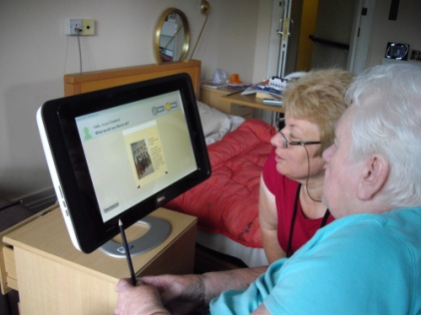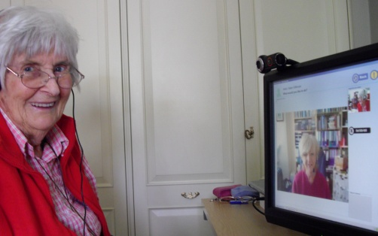
The workshop will launch a workbook commissioned by Department of Health, North East Older Adult Programme aimed at sharing good practice relating to social interaction.
There is no charge for this workshop, however, places are limited and will be allocated on a first come basis. To book a place please contact Rosemary Reay 0191 2156693 or email rosemary.reay@northumbria.ac.uk

